(10)-Determine the specific volume (ʋ), in ft³/lb_{m}, of Sulfur dioxide (SO₂) at 760.7 psi and 353.75 ⁰F, using the attached Generalized Compressibility Chart.
(Please mark your work on attached chart to identify Z).
(Show the full details of your calculation here)! Carry the given system of units!
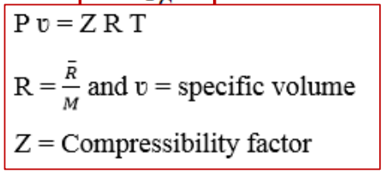
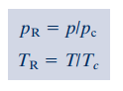

From Table A-1E, $p_{c}=77.7 atm, T_{c}=775 R°, M=64.06 lb/lbmol$
$$T_{R}=\frac{353.75+459.67}{775}=1.04957$$
$$p_{R}=\frac{\left(\frac{760.7}{14.7}\right)}{77.7}=0.666$$
$$Z=0.78$$
$$R=\frac{\overline{R}}{M}=\frac{1545}{64.06}=24.118$$
$$v=\frac{ZRT}{P}=\frac{0.78*24.118*813.42}{760.7*144}=0.139\frac{ft^{3}}{lb}$$

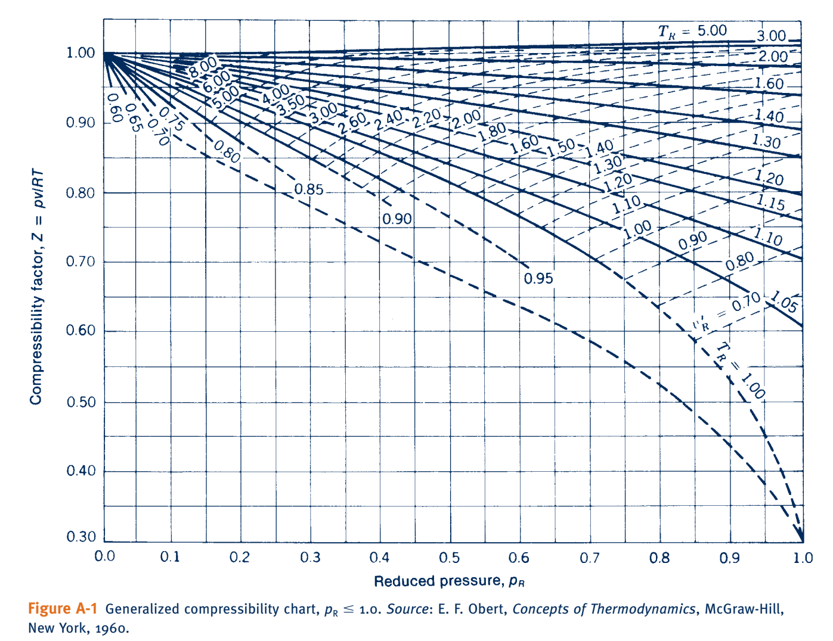

- (15 points)-Refrigerant 134a enters a horizontal pipe operating at steady state at 60 ⁰C, 0.5 MPa, and a velocity of 50 m/s. At the exit, the temperature is 70 ⁰C and the pressure is 0.28 MPa. The pipe diameter is 0.05 m. Show full details of your calculation. Determine:
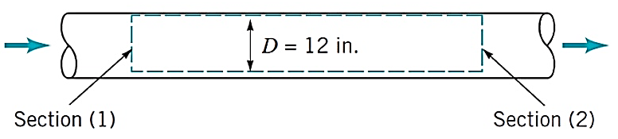

0.05 m
T₁ = 70 ⁰C
P₁ = 0.28 MPa
V₁ =?
T₁ = 60 ⁰C
P₁ = 0.5 MPa
V₁ = 50 m/s
m₁=?

$$\dot{m}=\frac{AV}{v}$$
Q = A V

- (2 points)-The mass flow rate of the refrigerant 134 a, in kg/s?
$v=$Assuming superheated: 0.05403. Using Pressure: 0.0409. Using Temperature: 0.0114
#1 Superheated: $\dot{m}=\frac{50*{\left(\frac{0.05}{2}\right)}^{2}*π}{0.05403}=1.817$
#2 Pressure Table(vapor): $\dot{m}=\frac{50*{\left(\frac{0.05}{2}\right)}^{2}*π}{0.0409}=2.4$
#3 Temperature Table (Vapor): $\dot{m}=\frac{50*{\left(\frac{0.05}{2}\right)}^{2}*π}{0.0114}=8.611$
- (2 points)-The velocity at the exit, in m/s ?
$$v=0.09641, 0.0719, 0.0086$$
#1 Superheated Table: $V=\frac{1.817*0.09641}{{\left(\frac{0.05}{2}\right)}^{2}*π}=89.217$
#2 Pressure Table: $V=\frac{2.4*0.0719}{{\left(\frac{0.05}{2}\right)}^{2}*π}=87.88$
#3 Temperature Table: $V=\frac{8.611*0.0086}{{\left(\frac{0.05}{2}\right)}^{2}*π}=37.71$

- (20 points)-For the desuperheater shown in figure, liquid water at state 1 is injected into a stream of superheated vapor entering at state 2. As a result, saturated vapor exits at state 3. Data for steady state operation are shown on the figure. Ignoring stray heat transfer and kinetic and potential energy effects, determine the mass flow rate of the incoming superheated vapor, in kg/min.

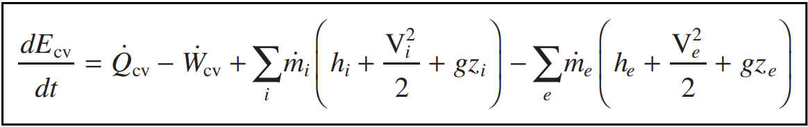
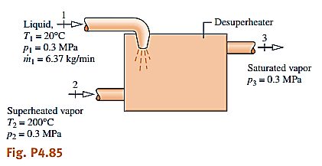
$${\dot{m}}_{3}={\dot{m}}_{2}+{\dot{m}}_{1}$$
$$0=6.37\left(h_{1}\right)+{\dot{m}}_{2}\left(h_{2}\right)-({\dot{m}}_{2}+6.37)\left(h_{3}\right)$$
From Table A-2, $h_{1}=83.96$, From Table A-3, $h_{3}=2725.3$, From Table A-4, $h_{2}=2865.5$
$$0=6.37\left(83.96\right)+{\dot{m}}_{2}\left(2865.5\right)-\left({\dot{m}}_{2}+6.37\right)\left(2725.3\right)→{\dot{m}}_{2}=120 kg/min$$

- (20 points)-Figure provides steady-state operating data for a pump drawing water from a reservoir and delivering it at a pressure of 3 bar to a storage tank perched above the reservoir. The mass flow rate of the water is 1.5 kg/s. The water temperature remains nearly constant at 15⁰C, there is no significant change in kinetic energy from inlet to exit, and heat transfer between the pump and its surroundings is negligible. Determine the power required by the pump, in kW. Let g = 9.81 m/s².
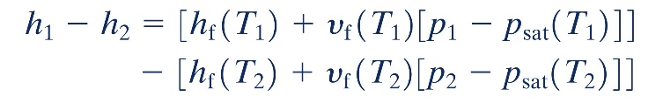
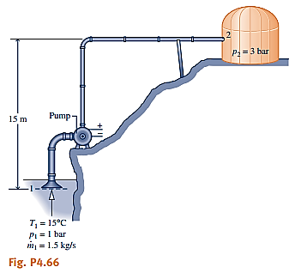
$$\dot{Q}+\dot{W}=\dot{m}\left(\left(h_{1}-h_{2}\right)+\frac{g\left(z_{1}-z_{2}\right)}{1000}\right)$$
$$h_{1}-h_{2}=\left[h_{f}\left(T_{1}\right)+v_{f}\left(T_{1}\right)\left[p_{1}-p_{sat}\left(T_{1}\right)\right]\right]-\left[h_{f}\left(T_{2}\right)+v_{f}\left(T_{2}\right)\left[p_{2}-p_{sat}\left(T_{2}\right)\right]\right]$$
$$h_{1}-h_{2}=(62.99+0.0010009\left(100-1.705\right)-(62.99+0.0010009\left(300-1.705\right)=-0.20018$$
$$\dot{W}=1.5\left(-0.20018+\frac{9.81*-15}{1000}\right)=-0.52 kW$$

- (15 points)-Steam exits turbine with quality X₁ = 96 % and mass flow rate of m₁ = 3.60 x 10⁵ kg/h at P₁ = 0.1 bar. Then the condensed steam leaves condenser as saturated liquid at constant pressure P₂ = 0.1 bar. Cooling water enters the condenser at 15 ⁰C and leaves the condenser at 40 ⁰C with negligible change in pressure. The steam and the cooling water streams do not mix. Neglecting stray heat transfer and ignoring kinetic and potential energy effects. Assuming steady state condition, determine the mass flow rate of the cooling water in kg/h. Show the full summary of your energy rate balance equations for full credit. Plug in number will not be accepted.
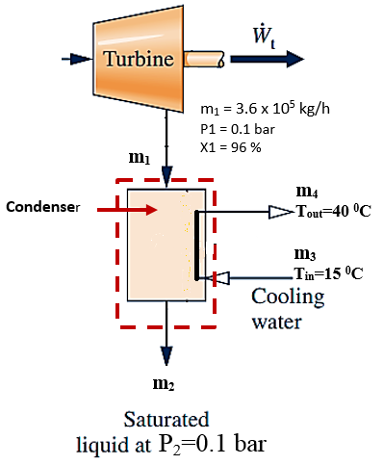

$$\dot{W}={\dot{m}}_{1}\left(h_{1}\right)+{\dot{m}}_{3}\left(h_{3}\right)-\left({\dot{m}}_{2}\left(h_{2}\right)+{\dot{m}}_{4}\left(h_{4}\right)\right)→0={\dot{m}}_{1}\left(h_{1}\right)+{\dot{m}}_{3}\left(h_{3}\right)-\left({\dot{m}}_{1}\left(h_{2}\right)+{\dot{m}}_{3}\left(h_{4}\right)\right)$$
$$h_{1}=h_{f}+x\left(h_{fg}\right)=191.83+0.96\left(2392.8\right)=2488.918$$
$$h_{2}=191.83, h_{3}=62.99, h_{4}=167.57$$
$$0=3.6*{10}^{5}*\left(2488.918\right)+{\dot{m}}_{3}\left(62.99\right)-\left(3.6*{10}^{5}*\left(191.83\right)+{\dot{m}}_{3}\left(167.57\right)\right)=7.9*{10}^{6} kg/h$$

